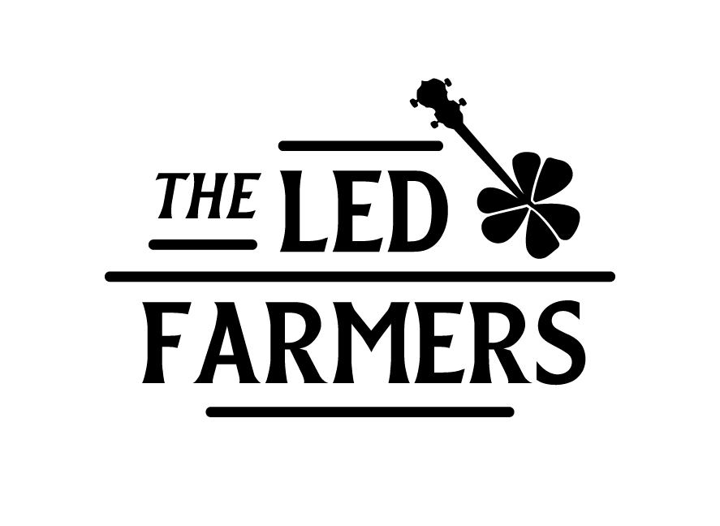

Biography:
The Led Farmers are an Irish Folk band from Ireland and Switzerland. The group boasts a two-time All Ireland Music champion and many of it’s members have studied music at University level. They have performed throughout Europe and the U.S. They play a wide range of Irish Folk songs, Traditional Irish sets, original songs and some cover songs. Their spontaneous nature and friendliness on the stage makes them one of the most entertaining live bands.

What the media says:
‘The Led Farmers are the kind of act that you just want to see go far, they have a likeability factor and stage presence that just completely enhances their performance and makes them so distinctive in comparison to so many trad/folk groups out there at the moment’ - Dublin Concerts reviews

‘According to Merriam Webster Dictionary, the word ‘fresh’ has the following meaning: having its original qualities unimpaired, full of or renewed in vigor and not worn or rumpled… and here comes a band that seems to fit the bill… they are infectious likeably and distinctive, these are lads you might indeed want to join for a pint or two’ - Irish American News

‘The Led Farmers preserve the tradition of their own native songs while adding a decidedly unique perspective to it. I can see that if The Led Farmers can persist like the Clancy Brothers did. Maybe in 20 or 30 years it may be said that they helped set the new standard for traditional Irish Music’ - Paddy Rock

‘I like the vibe of The Led Farmers. They have an acoustic sound that reminds me of Dexys Midnight Runners. These lads have an energy and style that takes up where the Pogues left off’ - Christy McNamara

